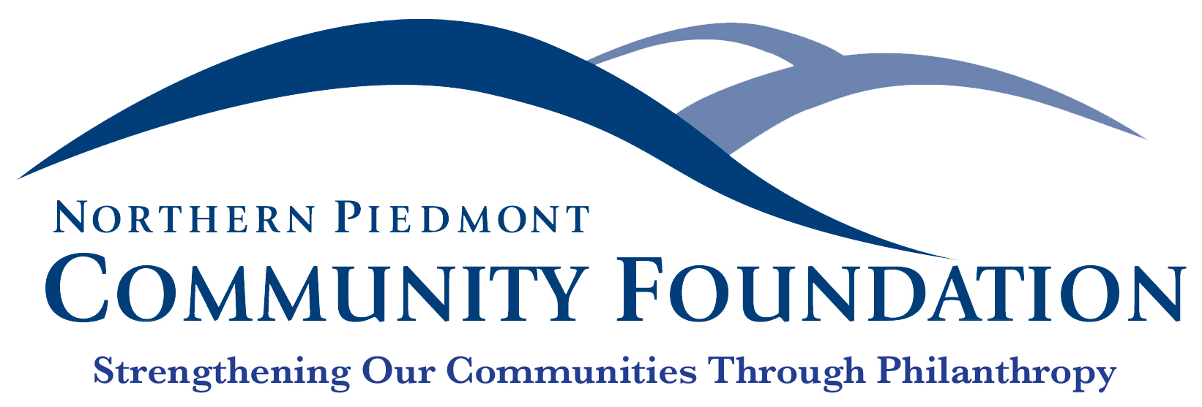

FOR IMMEDIATE RELEASE Contact: Jane Bowling-Wilson
July 19, 2019 540-349-0631

Empowering Rappahannock Families though the work of the Nonprofit Sector

Warrenton, VA—Thanks to a host of local grants, 2019 could be named “The Year of Celebrating Life” in Rappahannock County, where more than $32,000 from the Northern Piedmont Community Foundation was recently disbursed to various nonprofits that are dedicated to helping residents thrive throughout their lifetimes, from early childhood through to senior citizens.

The Child Care and Learning Center (CCLC) is using a $15,000 Community Assistance Grant to fund its First Step program, which allows children at or below 100% of the federal poverty level to attend CCLC’s pre-school 3’s class for the 2019–20 year. This classroom provides children with opportunities to play, structured group learning activities, reading, math, and outdoor time. Participants continue to develop the ability to pay attention, listen, receive direction, and moderate their behavior—all skills that have been identified as preparing kids for kindergarten and elementary school. In addition, these children receive transportation to and from CCLC, before- and after-school care, and “Backpack” meals. Families with a participating child work directly with the family support coordinator and are provided with opportunities to attend parenting classes and other events.

Dedicated to lifelong learning and workforce training for adults within the county, RappU is using a $15,000 Community Assistance Grant to help with program expansion and equipment upgrade. A big part of the expansion included its relocation to the Sperryville Schoolhouse, which allows enough space for Lord Fairfax Community College and other outside groups to offer courses. In addition, they now offer a Limited Radiologic Technologist program, which has permitted them to expand into the online learning environment in, and an upcoming Cyber Security class provides the opportunity to partner with both the high school and community college while attracting both men and women into the program. The grant is also funding a CPR/AED upgrade, which is not only required by the American Heart Association but is critical to serve the needs of Rappahannock County Public Schools.

And finally, some of the county’s older citizens are benefiting from a $2,500 Community Assistance Grant to Rapp at Home, whose mission is to reduce social isolation and provide access to services that help individuals ages 50+ live in the community safely, comfortably, and independently. The organization also hope to spearhead new initiatives to better meet the transportation and other social and fitness needs of the county’s senior citizens.

Community Assistance Grants and a variety of other grants available to Rappahannock County nonprofit organizations are managed and disbursed by the Northern Piedmont Community Foundation.
To learn more, visit npcf.org.

Established in 2000, the Northern Piedmont Community Foundation is a public charity that strengthens the counties of Culpeper, Fauquier, Madison, and Rappahannock through philanthropy. The Foundation supports our nonprofit sector through donor giving, community grants, as well as a robust scholarship program.
###

