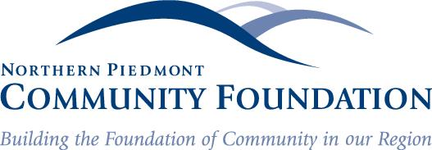

FOR IMMEDIATE RELEASE Contact: Jane Bowling-Wilson
May 13, 2019 540-349-0631

An Outstanding Sixth Year for Give Local Piedmont:
$$893,000 Raised for 177 Participating Organizations

Warrenton, VA—The sixth annual 24-hour Day of Giving raised more than $893,00 for 177 participating regional nonprofits. 2019 is a record year in both donations and number of nonprofit organizations participating. Over 155 of the 177 participating charities received 10 or more donations. 20% of the participating organizations received over $5,000 in donations. The minimum donation for the day was $10. The highest single donation was $12,000.
Included in the $893,000 is a $100,000 donation from the PATH Foundation that is distributed proportionately among all participating nonprofits. Additionally, high school seniors in 8 different public and independent schools in Culpeper, Fauquier and Rappahannock counties also donated to nonprofits through a program that introduces young people to philanthropy, supported by the PATH Foundation. This year our young people gave to organizations doing work in these areas; animals (20.5%), health (19.5%), human services (17.9%), youth development (12.8%) and education (12.5%).
In Culpeper County, 42 organizations raised approximately $132,000, 14 nonprofit organizations in Madison County raised $28,400, while 83 Fauquier nonprofits tallied $380,200 and 37 Rappahannock organizations raised $222,428.
The genuine win for our community from this one giving day is that “Give Local Piedmont” has helped in raising the profile for many of our nonprofit organizations and the tremendous work they do to strengthen our region.” said NPCF Executive Director Jane Bowling-Wilson. “It is an exciting event that builds awareness and participation for both our donors and nonprofits. The givelocalpiedmont.org website is a great source of information on organizations that contribute to our communities’ well-being. County donations and support exhibited through this one-day campaign are nothing short of spectacular.”

A special thank you to our Give Local Piedmont Community Foundation fund sponsors - The Doeller Family Fund, Nancy M. and Michael D. Baudhuin Foundation, The Rodgers Family Fund, the Red Oak Fund and the Linda and William Dietel Foundation. In addition, our business sponsors are perennial supporters of this event - thank you to Union Bank and Trust, Chemung Contracting Corp. & Cedar Mountain Stone, Oak View National Bank, and UVA Credit Union for generously supporting Give Local. Without their support, we could not facilitate the program. Warrenton Toyota, Clevenger Corner Veterinary Care, Lee High Nursery, Far Gohn Brewing, Robin Gulick, Xpress Copy and Graphic and The Fauquier Bank deserve a pat on the back and a thank you as do all our media and news sponsors whose contributions are, in one word, remarkable.

Established in 2000, the Northern Piedmont Community Foundation is a public charity that strengthens the counties of Culpeper, Fauquier, Madison, and Rappahannock through philanthropy. The Foundation supports our nonprofit sector through donor giving, community grants, as well as a robust scholarship program.
###

