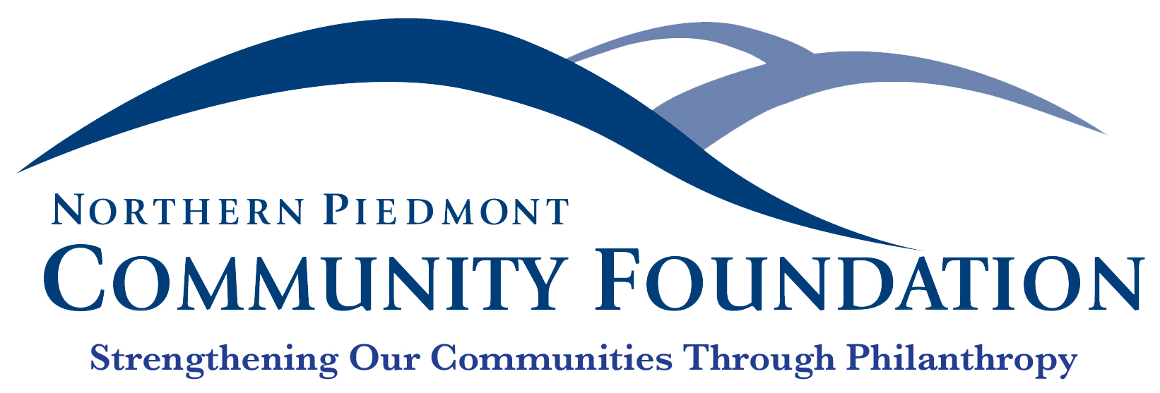

FOR IMMEDIATE RELEASE Contact: Jane Bowling-Wilson
July 19, 2019 540-349-0631

Empowering Madison County Families though the work of the Nonprofit Sector

Warrenton, VA—Thanks to $2,500 in grants recently disbursed by the Northern Piedmont Community Foundation, local residents from children to senior citizens are getting a hand up this summer.

Approximately 130 youth participating in the Boys & Girls Clubs of Madison will enjoy tasty and nutritious afternoon snacks this summer thanks in part to a $500 grant from the Meade M. Palmer Memorial Fund. Because of its access to a high-needs youth population, the Club annually facilitates the Summer Meals Program in partnership with Madison County Public Schools. This federally funded, state-administered program provides no-cost meals to youth 18 years old and younger when school is out of session, filling in the gaps for students who count on school breakfast and lunch during the school year, but lose that resource in the summer. The USDA-compliant snacks ensure that lunch isn’t their final meal before breakfast the following morning.

Youth attending Camp Unakite this summer are partially sponsored by a $1,000 grant from the Meade M. Palmer Memorial Fund. This STEM educational opportunity for rising third through ninth grade students is held at historic Graves Mountain Lodge, where students explore our natural world through science, technology, engineering, and math. The one-week camp uses STEM activities to reinforce and augment school-year instruction, helping campers make both academic and soft skills gains that prepare them for future academics, jobs, and life.

Skyline CAP, Inc. also received a $1,000 Meade M. Palmer Memorial Fund grant to complete several emergency home repairs for income-eligible seniors and disabled citizens within the county. The organization’s Emergency Home Repair Program provides services for owner-occupied homes in need of basic health and safety repairs including plumbing, electrical, safety, and accessibility. Provided repairs ensure that citizens live independently in homes that are safe, healthy, and include accessibility to facilities, both inside and outside the home. Projects may include roof repairs, minor electrical and plumbing repairs or replacements, wheelchair ramp installations, widening of doorways, and bathroom upgrades to allow access for clients with disabilities. Not only do these repairs address safety issues, they eliminate the potential for significant health conditions to occur in people living in sub-par conditions.

Meade M. Palmer Memorial Fund grants and Madison County Community Fund grants are available to Madison County nonprofit organizations. These grants are managed and disbursed by the Northern Piedmont Community Foundation. To learn more, visit npcf.org.

Established in 2000, the Northern Piedmont Community Foundation is a public charity that strengthens the counties of Culpeper, Fauquier, Madison, and Rappahannock through philanthropy. The Foundation supports our nonprofit sector through donor giving, community grants, as well as a robust scholarship program.
###

