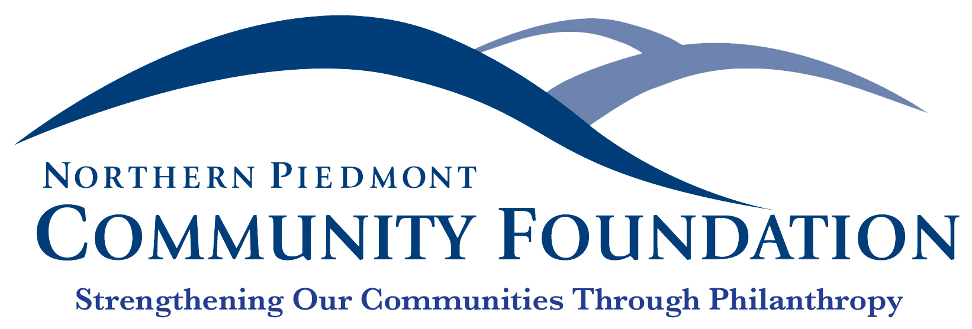

FOR IMMEDIATE RELEASE Contact: Jane Bowling-Wilson
July 19, 2019 540-349-0631

Empowering Culpeper’s Youth

Warrenton, VA—Thanks to a host of local grants, 2019 could be dubbed “The Year of the Child” in Culpeper County, as $42,000 was recently disbursed by the Northern Piedmont Community Foundation to various nonprofits that are dedicated to helping our young people thrive.

Adequate oral hygiene is essential for good health, and Piedmont Regional Dental Clinic (PDRC) is committed to providing it for our residents most in need. A $25,000 Community Assistance Grant is being used to provide emergency dental care for low-income Culpeper children who are ineligible for Medicaid. These children often experience severe oral infections and are in dire need of emergency dental care but have nowhere to turn for help. An ad hoc group of Culpeper organizations, including PDRC, collaborate to identify, educate, and care for these kids, whose families cannot afford the dental services that average about $1,250 each.

A national organization, Court Appointed Special Advocates (CASA) has more than two dozen regional offices throughout Virginia, and a $15,000 Community Assistance Grant is helping to establish the newest office in Culpeper County. People Inc. was selected to lead the CASA program in Culpeper because it has operated the CASA program in the 28th Judicial District in Southwest Virginia for a decade. CASA’s mission is to support and promote court-appointed volunteer advocacy so every abused or neglected child can be safe, have a permanent home, and have the opportunity to thrive. The grant helped to secure office space, hire a program coordinator, and recruit and train volunteers.

Research consistently connects studying music to higher performance across the academic spectrum. With tight school division budgets often resulting in cutting performing arts in schools, the need for after-school creative outlets is on the rise. Since its inception more than 30 years ago, Windmore Foundation for the Arts has striven to provide youth with literary, visual, and performing arts learning opportunities. Its Crossroads Youth Orchestra, an audition-based group, was launched seven years ago and has performed in multiple venues in Culpeper and surrounding counties. A $2,000 Culpeper Foundation Grant is being used to reach younger, less experienced students through lessons, which are open to residents in Culpeper, Fauquier, Madison, Orange, and Rappahannock counties.

Community Assistance Grants and Culpeper Foundation Grants are managed and disbursed by the Northern Piedmont Community Foundation. To learn more, visit npcf.org.

Established in 2000, the Northern Piedmont Community Foundation is a public charity that strengthens the counties of Culpeper, Fauquier, Madison, and Rappahannock through philanthropy. The Foundation supports our nonprofit sector through donor giving, community grants, as well as a robust scholarship program.
###

